A

Report on

**Online Examination Project**

**Developed By:**

SWAROOP KUMAR SAHU

MC2215

Department Of Computer Science

Berhampur University, Odisha

Bhanja Bihar, 760007

CONTENTS

1. Introduction
2. System Analysis
3. Feasibility Report
4. System Requirement Specifications
5. System Design
6. Technical Description
7. Testing with Screenshots
8. Codding
9. Scope
10. Conclusion

Introduction

Objective/ Vision

It provides a common platform to connect student and teacher online. The registered teacher can create Question and student can take question and can excel himself/herself.

Users of the System

1. Teacher
2. Student

Functional Requirements

**1. Teacher**

1. Can create question after getting logged in!
2. Can enter subjects and enter question with it?s options and answer at the time of creating question.
3. 10 Question for each question required to be completed.

**2. Student**

1. Can search question according to their interest.
2. Click on the id of question and ready to start it just clicking on a button.
3. After completing all questions, result will be diaplayed Automatically.
4. Can view the description about each and every question in the respective question.

Non-Functional Requirements

1. Secure access of confidential data (user?s details). SSL can be used.
2. 24 X 7 availability
3. Browser testing and support for IE, NN, Mozila, and Firefox
4. Reports exportable in .XLS, .PDF
5. Create a detailed UML diagram (Component, Sequence, Class) for the system and its sub-components

User Interface Priorities

1. Professional look and feel
2. Use of AJAX atleast with all registration forms and with every search option and at the id of each searched result with onmouseover event.

Tools to be used

1. Use any IDE to develop the project. It may be Myeclipse / Eclipse / Netbeanse.
2. Oracle 10g for the database.
3. Server: Apache Tomcat/JBoss/Glassfish/Weblogic/Websphere.

Front End and Back End

1. **Front End:** JSP, JDBC, Javascript, AJAX
2. **Back End:** Oracle

How project works?

To get detail explanation about project download the document file. It includes snapshots with explanation.

Software Requirement to run this project

1. You need to install an IDE Eclipse / Myeclipse / Netbeans.
2. Oracle 10g database. Here, we are using **system** for the username and **oracle** for the password.

Hot to run this project

Import the project on the IDE and run it. All the tables will be created automatically.

System Analysis

**Methodology:**

The way that is followed while carrying on with the developmentapplication is as follows:

It is always necessary to study and recognize theproblems of the existing system, which will help in finding outthe requirements for the new system. System study helps infinding different alternatives for better solution.The project study basically deals with different operationsand steps involved in it. It includes:1) Data gathering2) Study of existing system3) Analyzing problem4) Studying various documents5) Feasibility study for further improvementsFollowing are the steps taken during the initial study:



Initially, we collected all the information, which theywanted to store



Then we studied the working of the current system whichis done manually. We noted the limitations of that systemwhich motivated them to have a new system.



Then we analyzed the format of the reports generated bythat system.With the help of these documents we got basic ideas about thesystem as well as input and output of the developed InventorySystem

Feasibility Study

The feasibility study proposes one or more conceptual solutions tothe problem set for the project. The objective in assessing feasibility is todetermine whether a development project has a reasonable chance of success. It helps us to determine the input & output of the system. Thefollowing are the criteria that are considered to confirm the projectfeasibility.

**Technical Feasibility:**

At first it is necessary to check that the proposed systemis technically feasible or not and to determine the technologyand skill necessary to carry out the project. If they are notavailable then find out the solution to obtain them. Hardware isalready available in the college.

**Operational Feasibility:**

The operational feasibility is obtained by consulting withthe system users. Check that proposed solution satisfies theusers need or not.

SCREENSHOTS

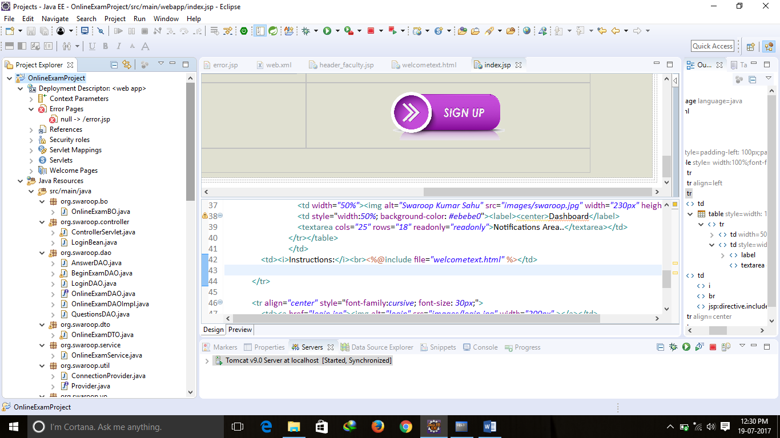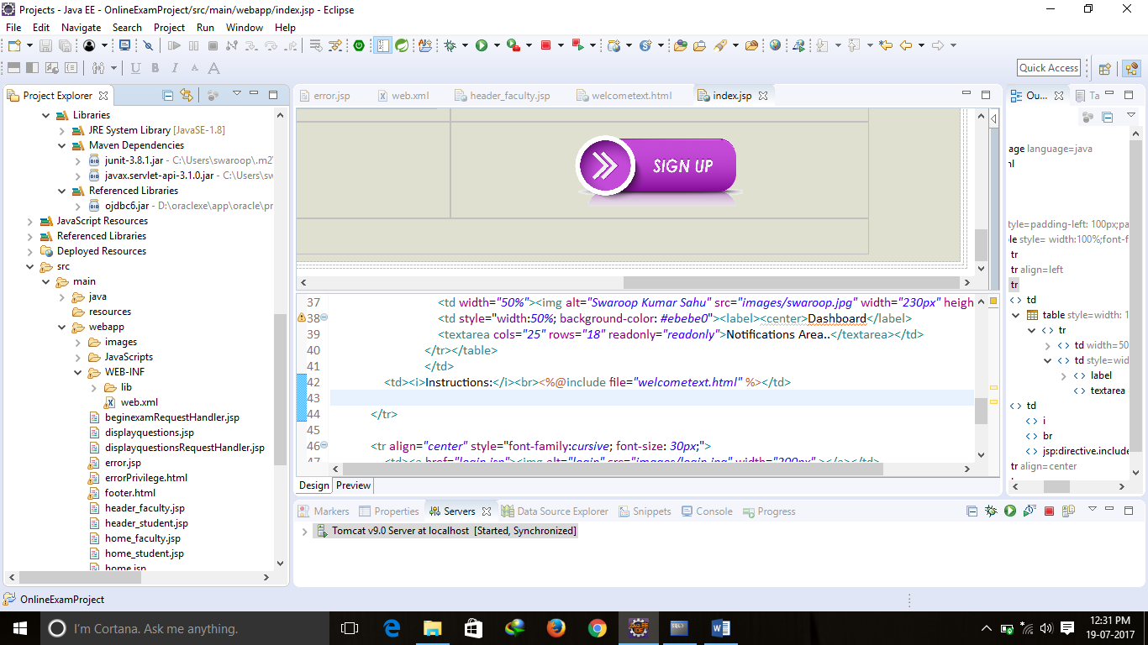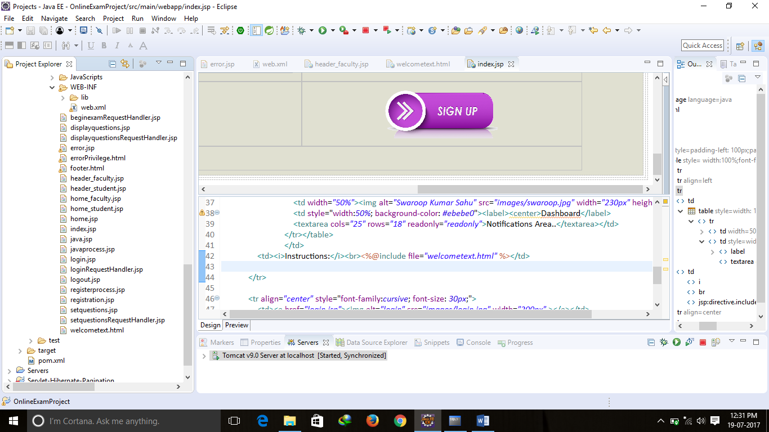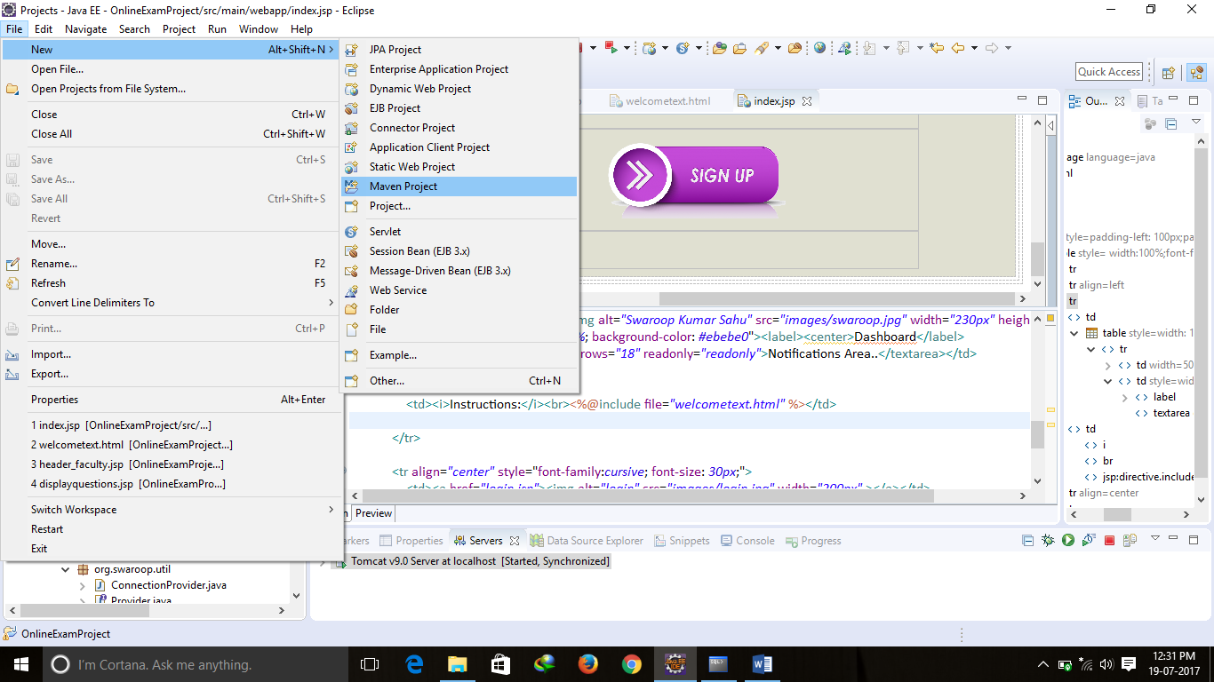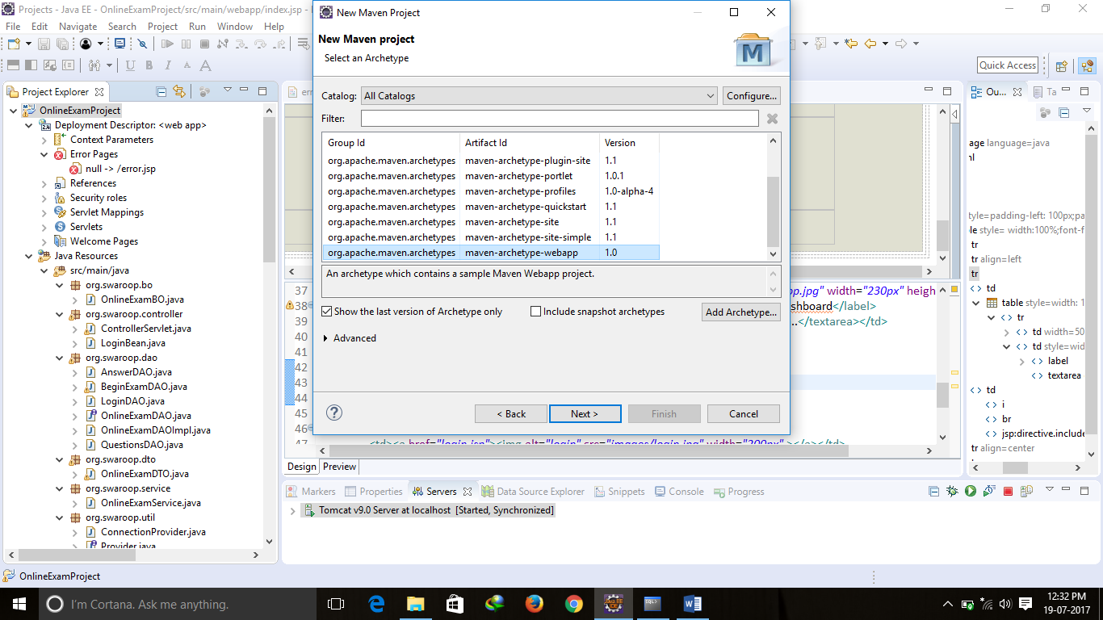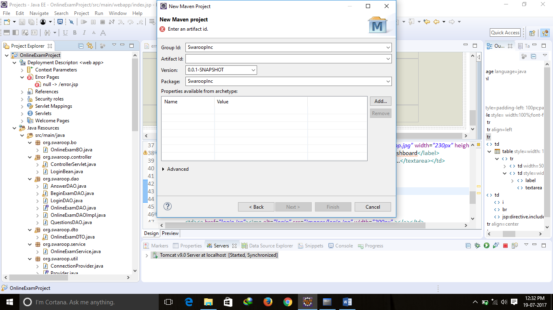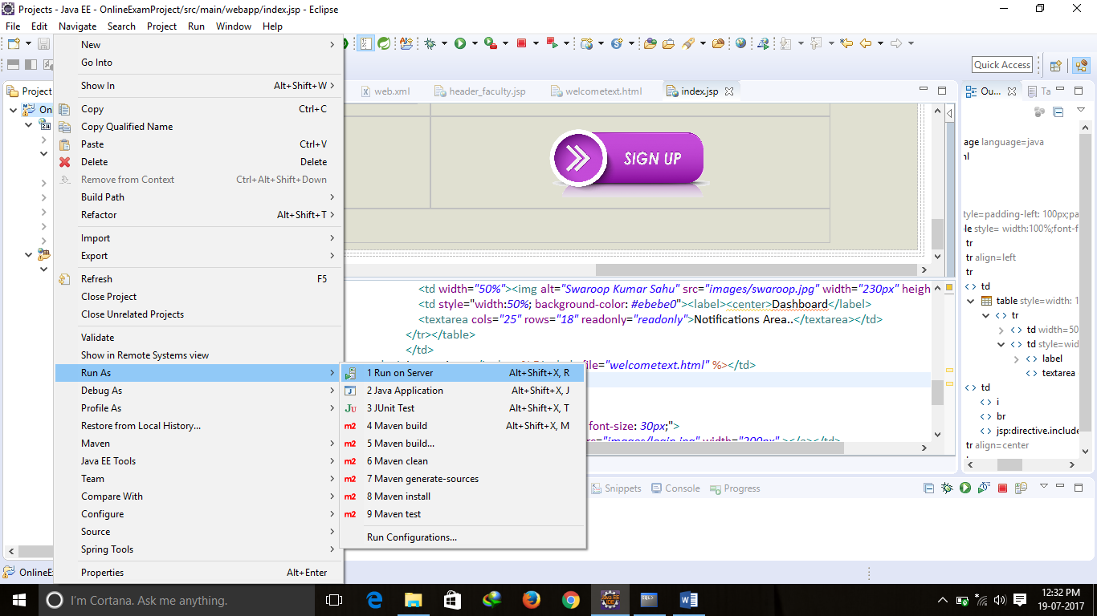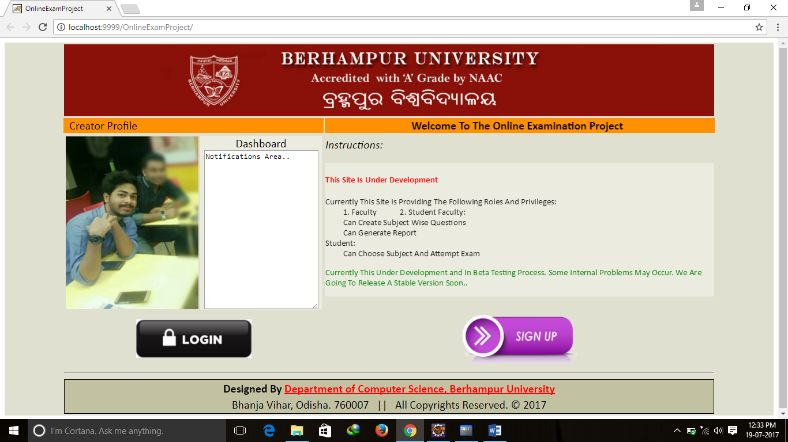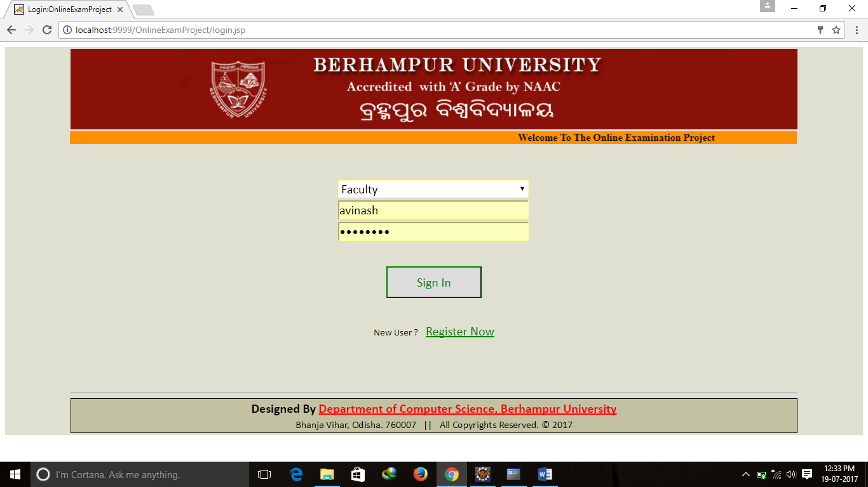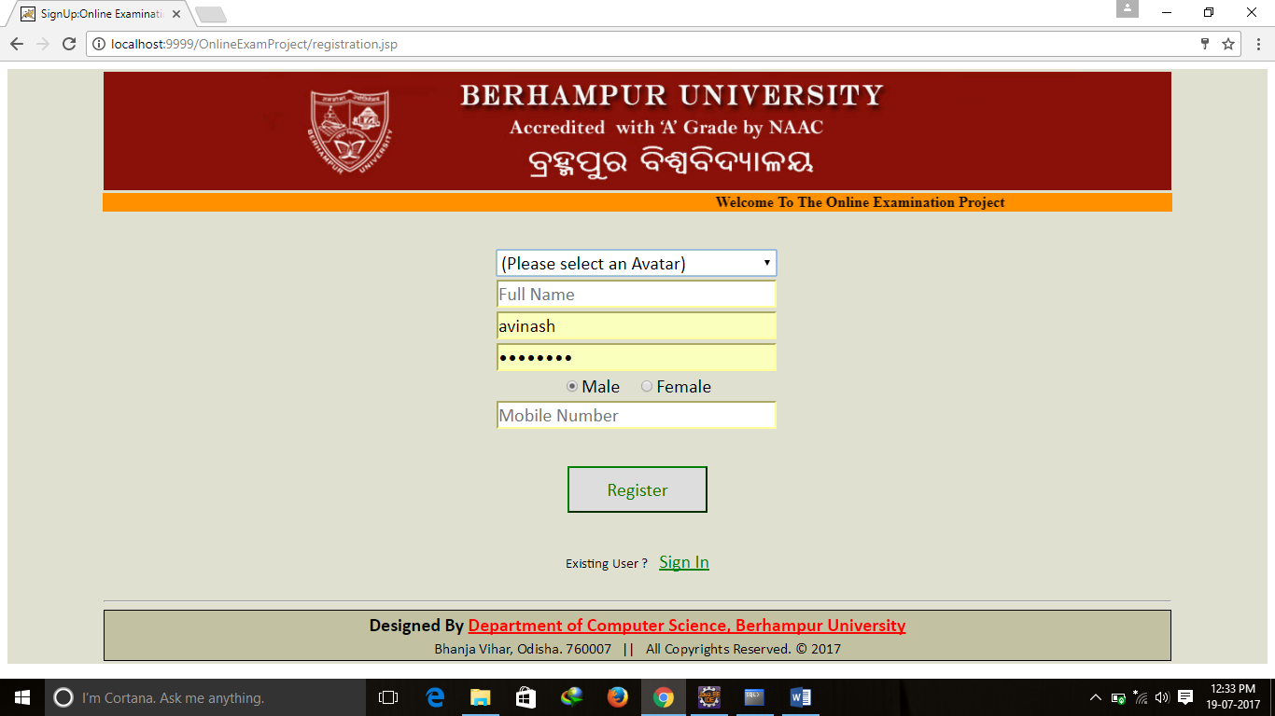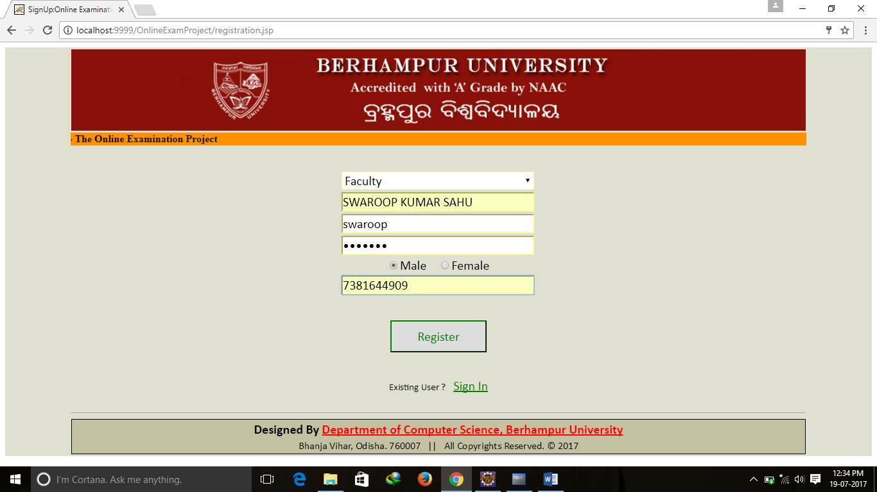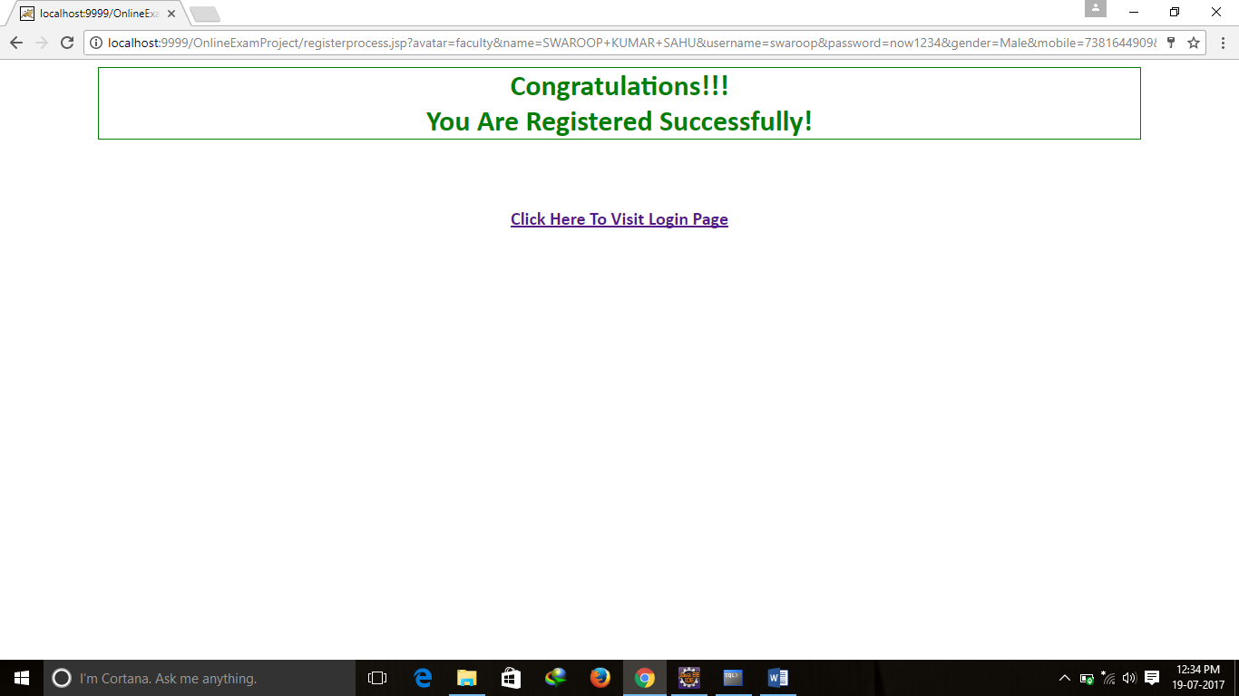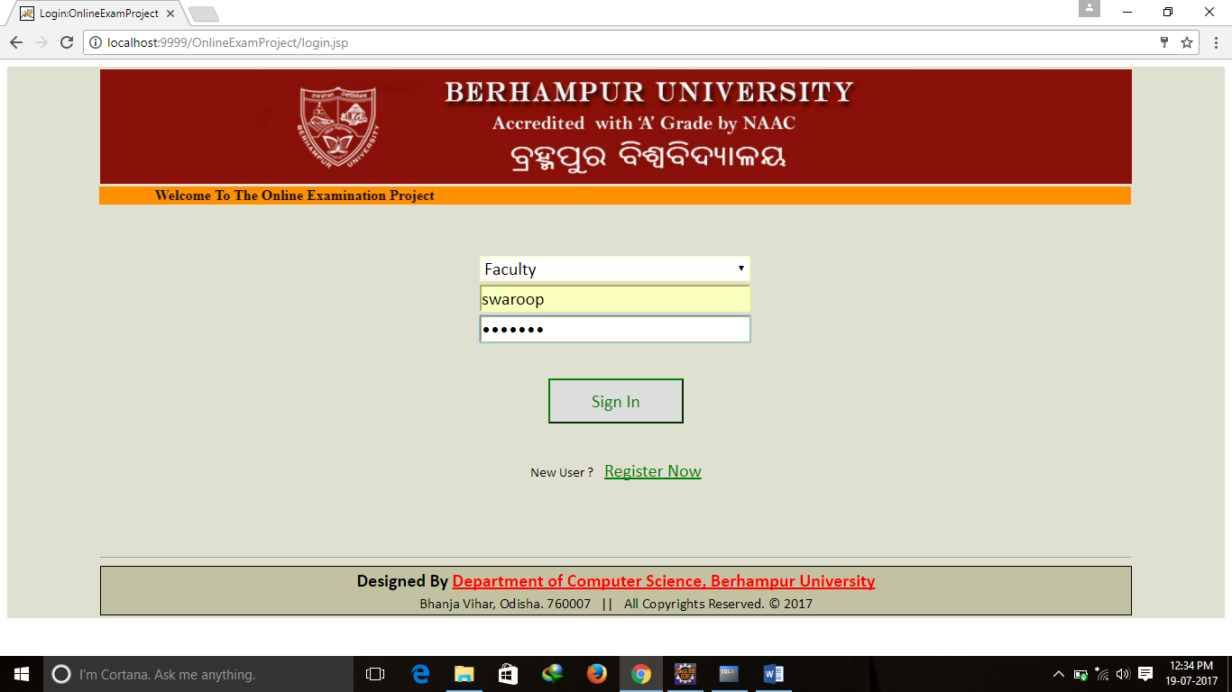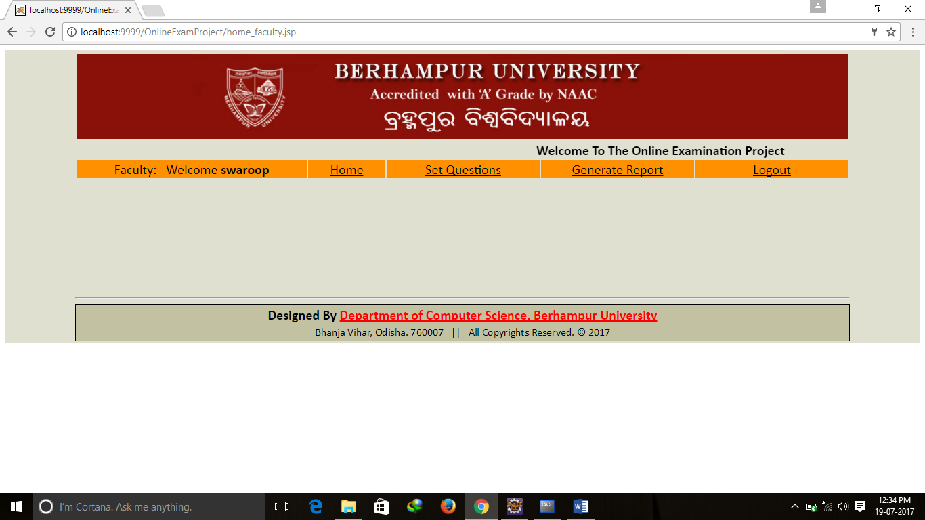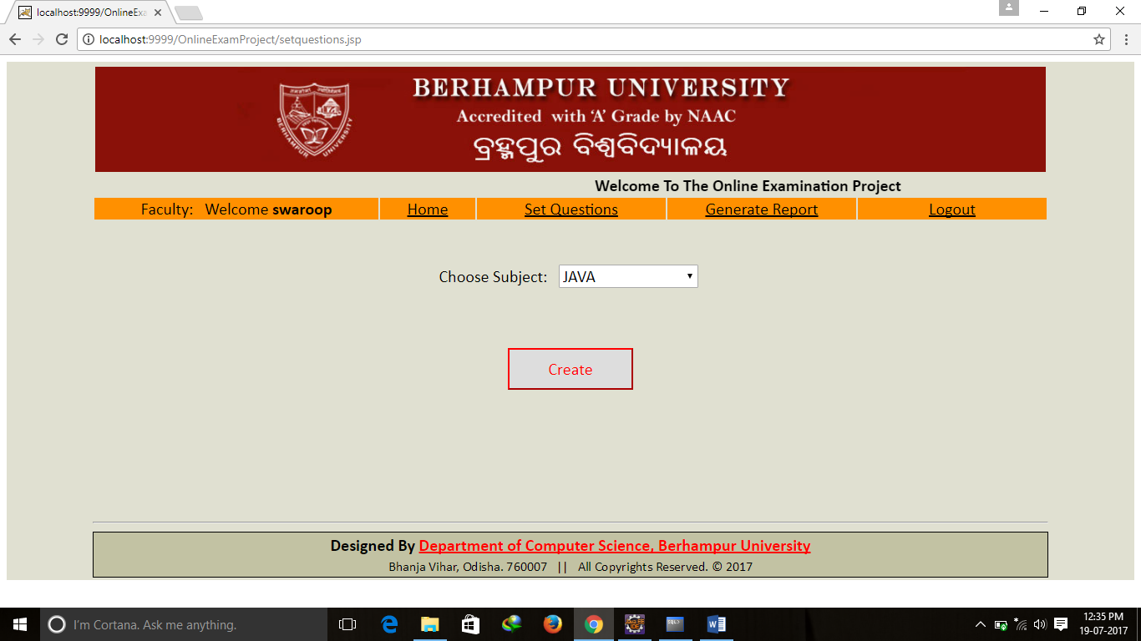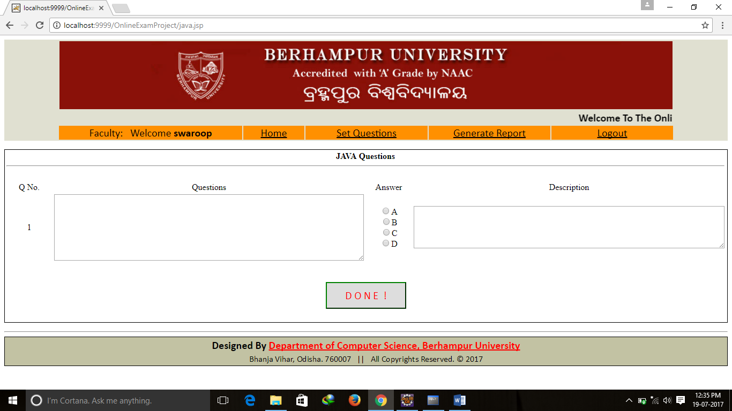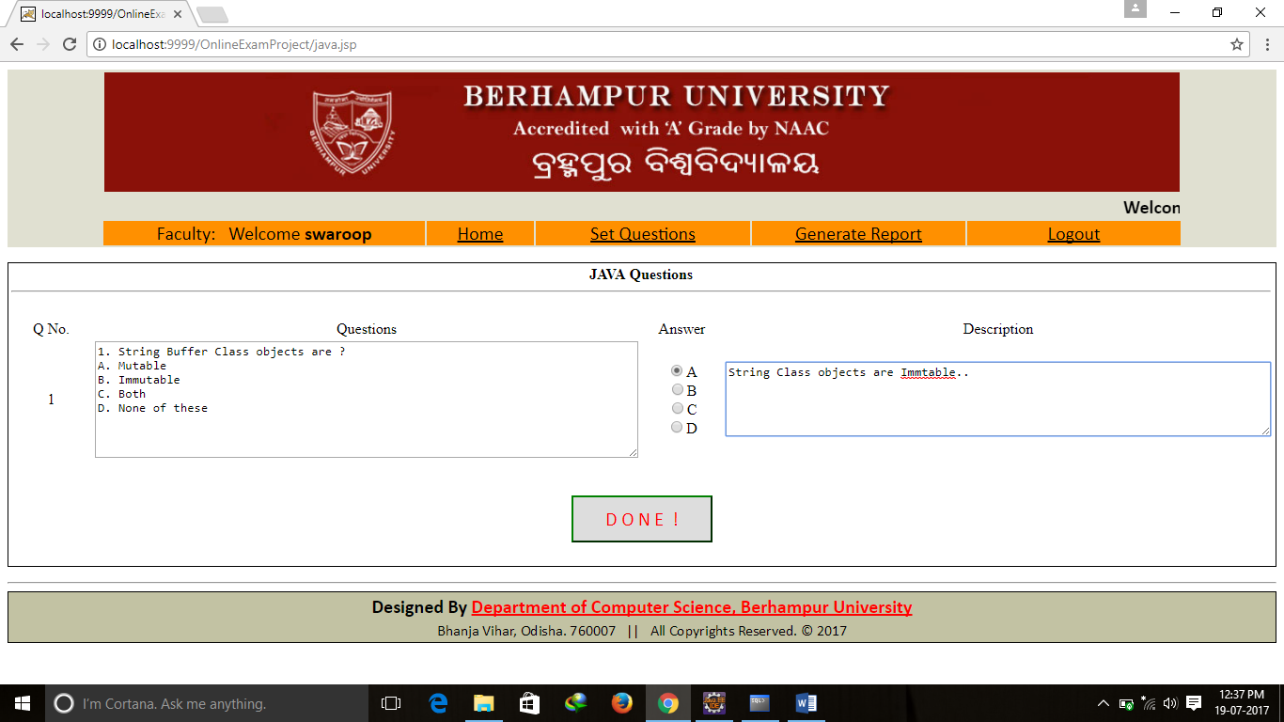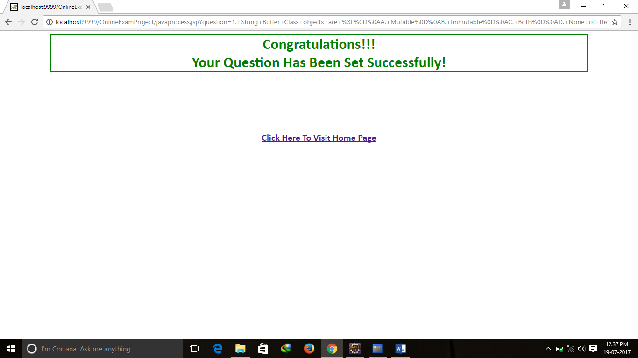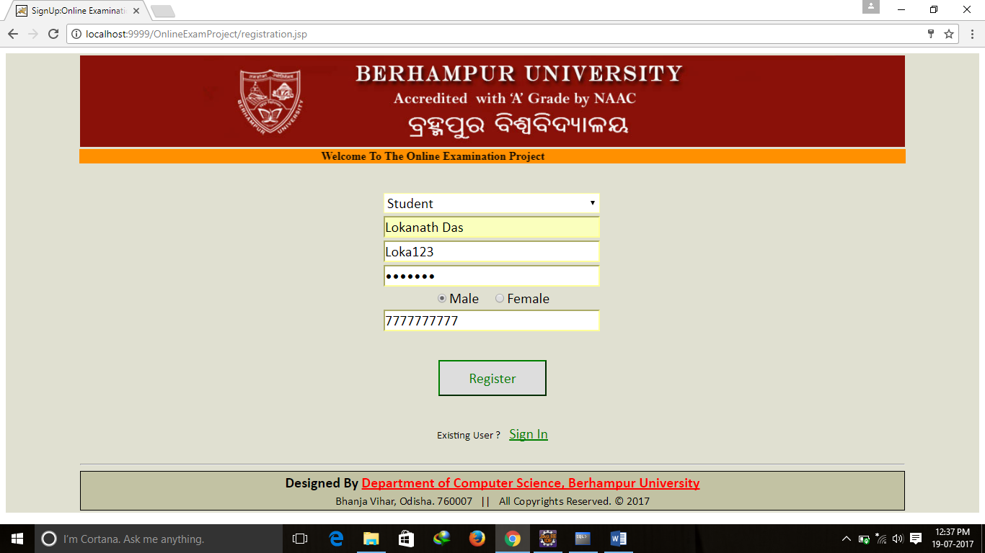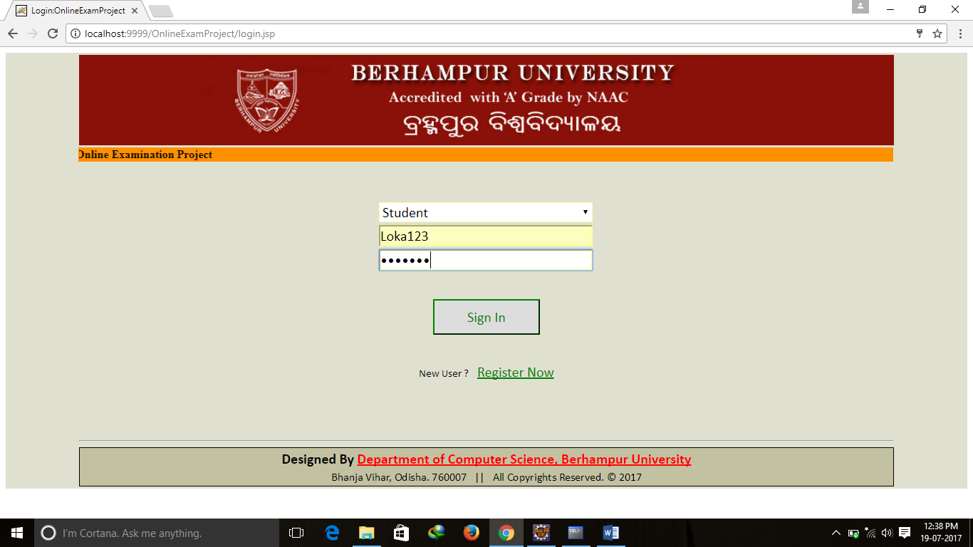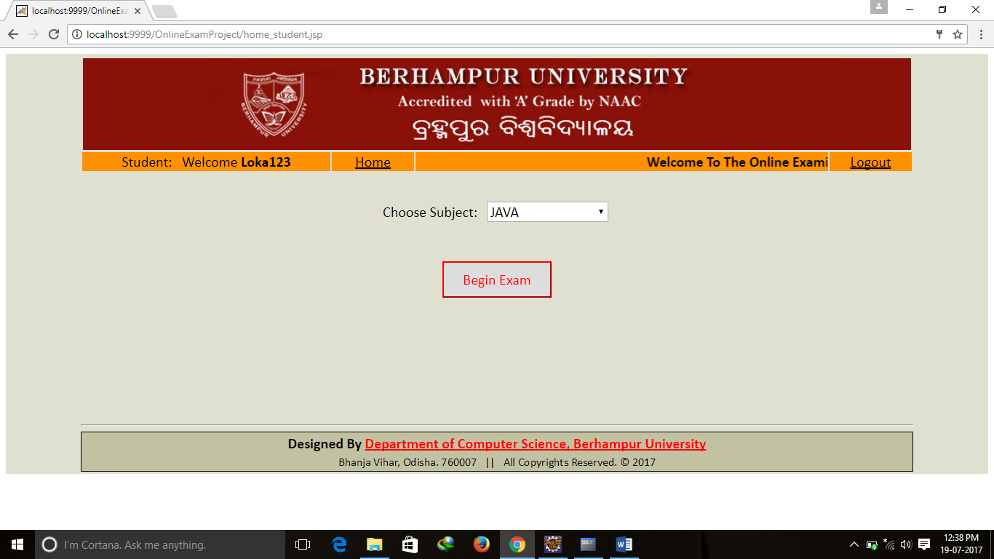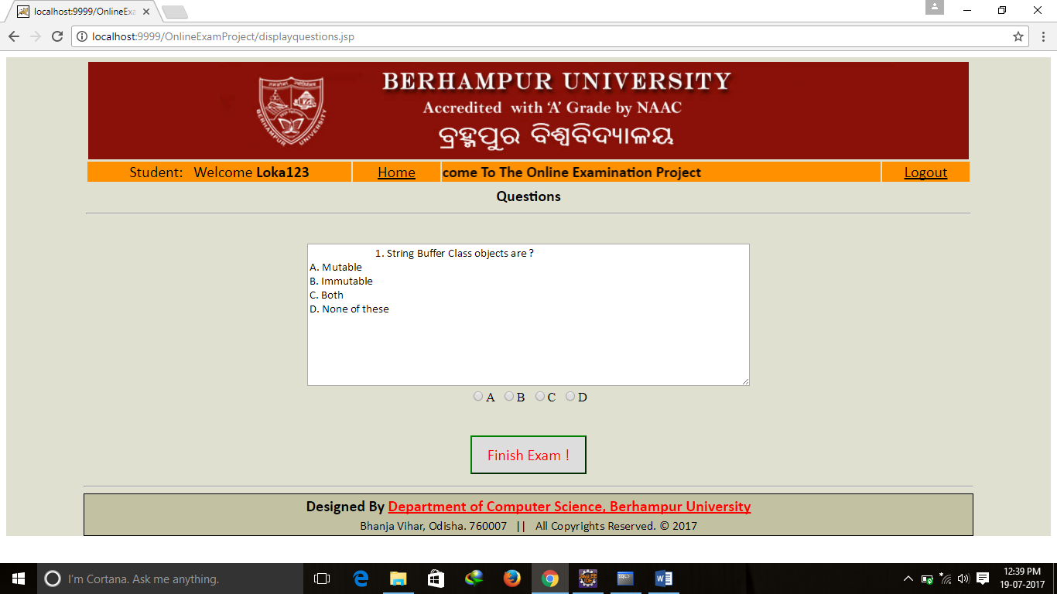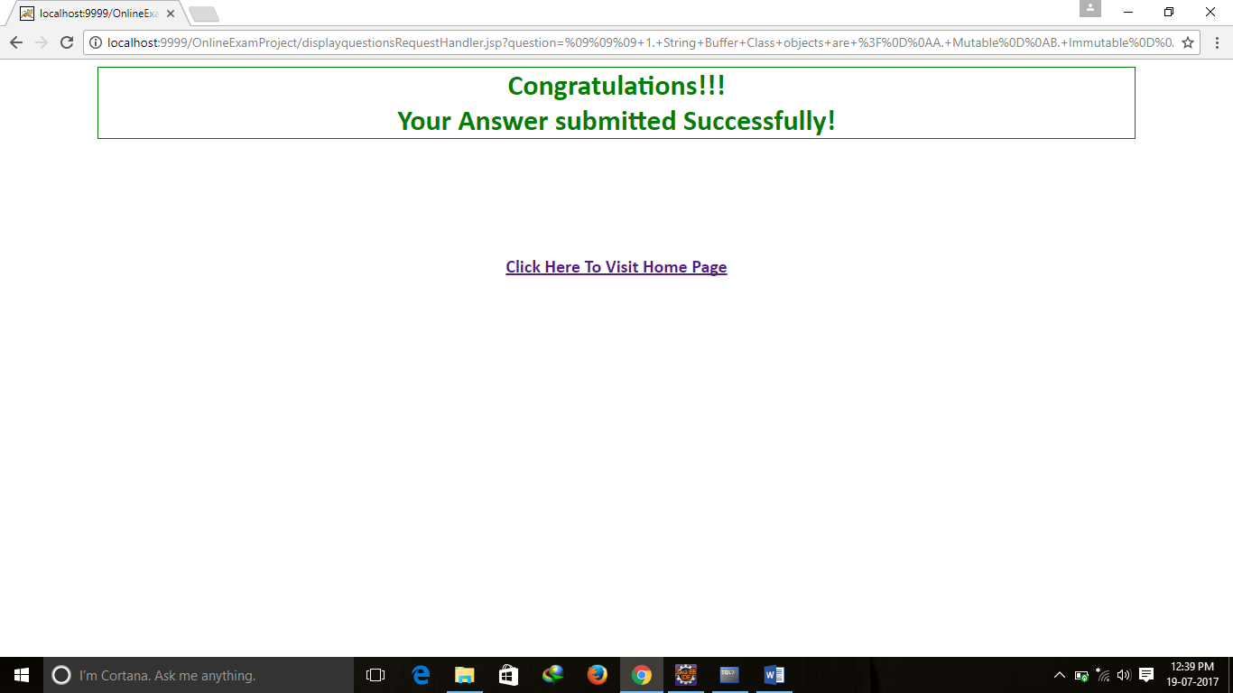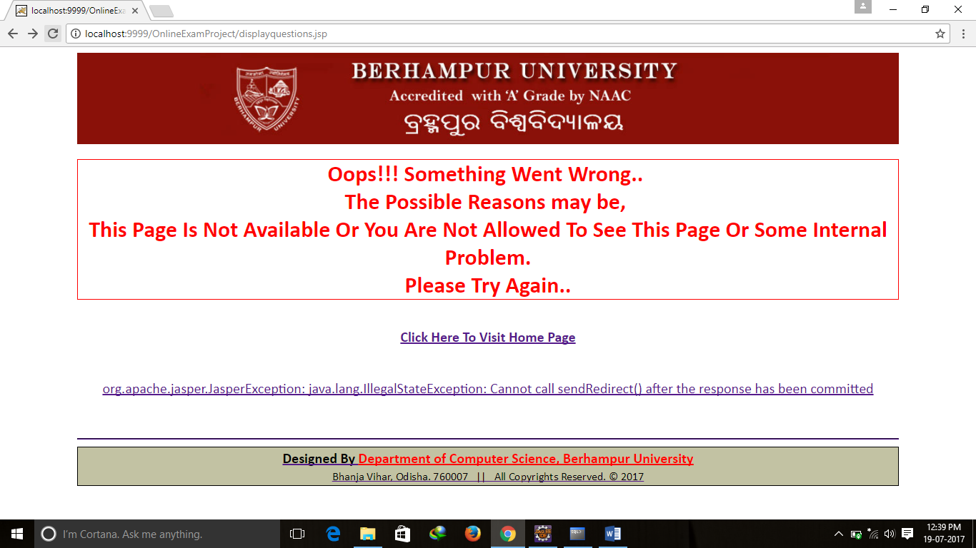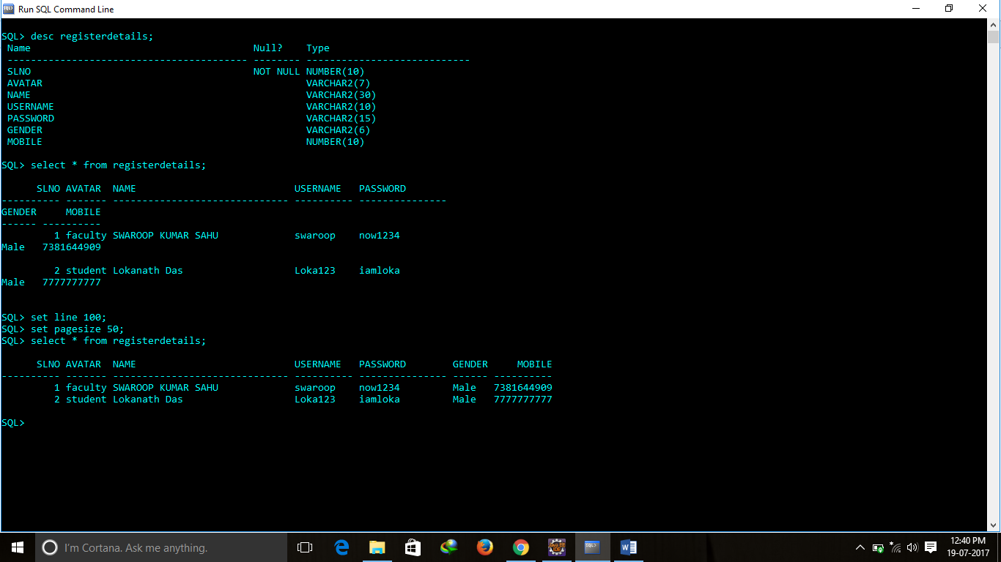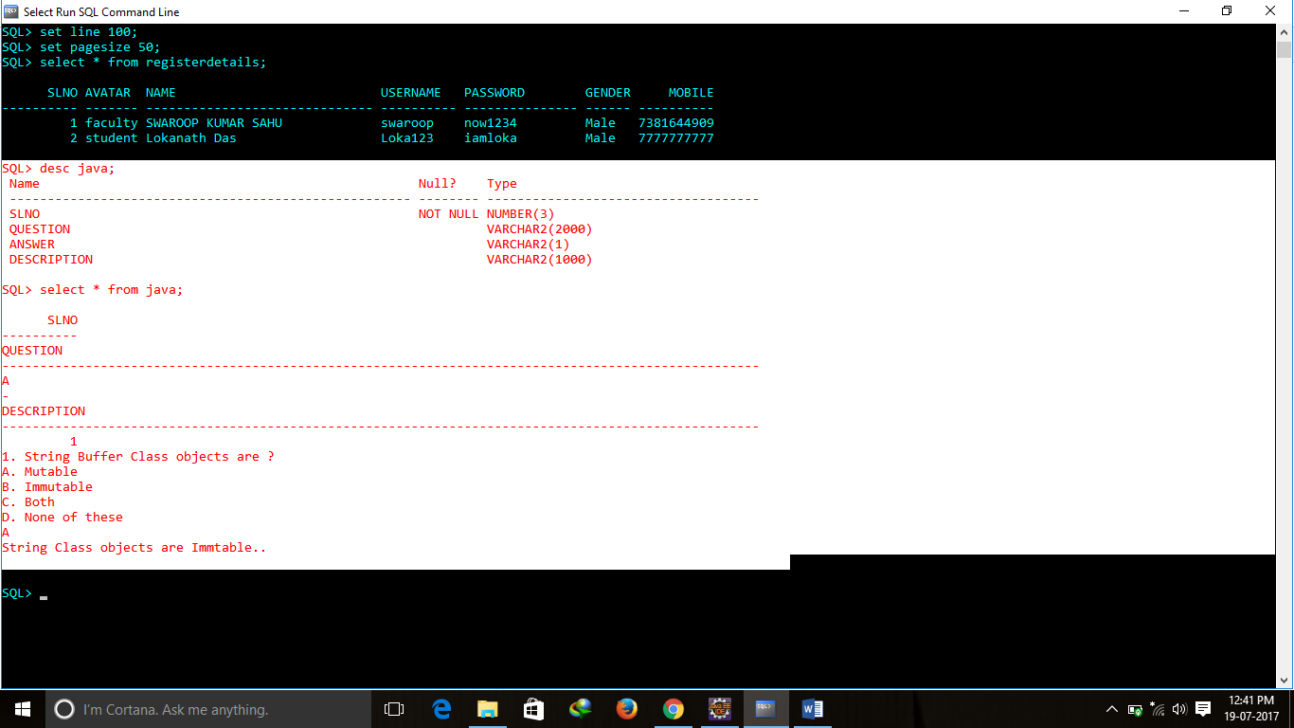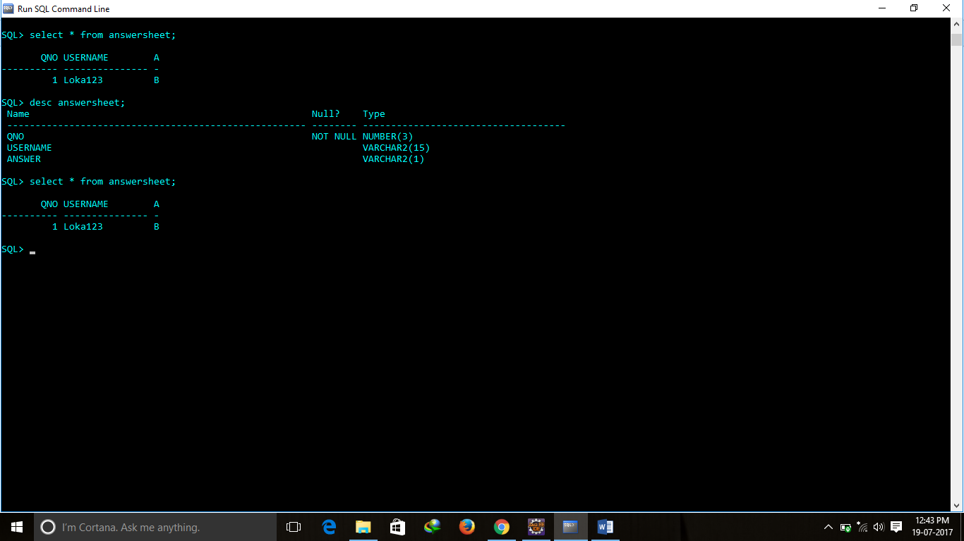

CODDING

**package** org.swaroop.bo;

**public** **class** OnlineExamBO {

**private** String avatar;

**private** String name;

**private** String username;

**private** String password;

**private** String gender;

**private** String mobile;

//Getters and Setters methods

**public** String getAvatar() {

**return** avatar;

}

**public** **void** setAvatar(String avatar) {

**this**.avatar = avatar;

}

**public** String getName() {

**return** name;

}

**public** **void** setName(String name) {

**this**.name = name;

}

**public** String getUsername() {

**return** username;

}

**public** **void** setUsername(String username) {

**this**.username = username;

}

**public** String getPassword() {

**return** password;

}

**public** **void** setPassword(String password) {

**this**.password = password;

}

**public** String getGender() {

**return** gender;

}

**public** **void** setGender(String gender) {

**this**.gender = gender;

}

**public** String getMobile() {

**return** mobile;

}

**public** **void** setMobile(String mobile) {

**this**.mobile = mobile;

}

}

**package** org.swaroop.controller;

**public** **class** LoginBean {

**private** String avatar;

**private** String username;

**private** String password;

//Setters and Getters

**public** String getAvatar() {

**return** avatar;

}

**public** **void** setAvatar(String avatar) {

**this**.avatar = avatar;

}

**public** String getUsername() {

**return** username;

}

**public** **void** setUsername(String username) {

**this**.username = username;

}

**public** String getPassword() {

**return** password;

}

**public** **void** setPassword(String password) {

**this**.password = password;

}

}

**package** org.swaroop.dao;

**import** java.sql.Connection;

**import** java.sql.PreparedStatement;

**import** org.swaroop.util.ConnectionProvider;

**import** org.swaroop.vo.AnswerVO;

**public** **class** AnswerDAO {

//Prepare Query

**public** **static** **final** String ***ANSWER_INSERT_QUERY*** = "INSERT INTO ANSWERSHEET(QNO,USERNAME,ANSWER) VALUES(?,?,?)";

**public** **static** **int** saveAnswer(AnswerVO vo) {

PreparedStatement ps = **null**;

**int** result = 0;

**try**{

//Get connection

Connection con=ConnectionProvider.*getCon*();

**if**(con!=**null**){

ps = con.prepareStatement(***ANSWER_INSERT_QUERY***);

}

//Getting and Setting Parameters values from AnswerVO class object

**if**(ps!=**null**){

ps.setInt(1, vo.getQno());

ps.setString(2, vo.getUsername());

ps.setString(3, vo.getAnswer());

//Execute Query

result = ps.executeUpdate();

//Process the result

**if**(result==0)

System.***out***.println("Record Not Inserted..!");

**else**

System.***out***.println("Record Inserted..!");

}//if

}//try

**catch**(Exception e){

e.printStackTrace();

}

**return** result;

}//method

}//class

**package** org.swaroop.dao;

**import** java.sql.Connection;

**import** java.sql.ResultSet;

**import** java.sql.Statement;

**import** org.swaroop.util.ConnectionProvider;

**import** org.swaroop.vo.QuestionsVO;

**public** **class** BeginExamDAO {

**public** **static** String retrievalQuery(QuestionsVO vo) {

//Getting subject parameter value from QuestionsVO class object

String subject = vo.getSubject();

String question = **null**;

Statement st = **null**;

ResultSet rs = **null**;

**try**{

//Get connection

Connection con=ConnectionProvider.*getCon*();

**if**(con!=**null**){

st = con.createStatement();

}

**if**(st!=**null**){

/*if(subject.equals("java")){*/

rs = st.executeQuery("SELECT QUESTION FROM JAVA");

/*}*/

//Process the ResultSet

**if**(rs!=**null**){

**while**(rs.next()){

question =rs.getString(1);

}

}//if

}//if

}//try

**catch**(Exception e){

e.printStackTrace();

}

**return** question;

}//method

}//class

package org.swaroop.dao;

import java.sql.Connection;

import java.sql.PreparedStatement;

import java.sql.ResultSet;

import org.swaroop.controller.LoginBean;

import org.swaroop.util.ConnectionProvider;

public class LoginDAO {

public static final String query = "SELECT * FROM REGISTERDETAILS WHERE AVATAR=? AND USERNAME=? AND PASSWORD=?";

public static String loginCheck(LoginBean bean){

try{

Connection con=ConnectionProvider.getCon();

PreparedStatement ps=con.prepareStatement(query);

ps.setString(1,bean.getAvatar());

ps.setString(2,bean.getUsername());

ps.setString(3, bean.getPassword());

ResultSet rs=ps.executeQuery();

if(rs.next()){

return "true";

}

else{

return "false";

}

}//try

catch(Exception e){

e.printStackTrace();

} //catch

return "error";

}

}

**package** org.swaroop.dao;

**import** org.swaroop.bo.OnlineExamBO;

**public** **interface** OnlineExamDAO {

**int** insertIntoRegisterDetails(OnlineExamBO obj);

}

**package** org.swaroop.dao;

**import** java.sql.Connection;

**import** java.sql.PreparedStatement;

**import** org.swaroop.bo.OnlineExamBO;

**import** org.swaroop.util.ConnectionProvider;

**public** **class** OnlineExamDAOImpl {

//Prepare Query

**public** **static** **final** String ***REGISTERDETAILS_INSERT_QUERY*** = "INSERT INTO REGISTERDETAILS(AVATAR,NAME,USERNAME,PASSWORD,GENDER,MOBILE) VALUES(?,?,?,?,?,?)";

**public** **static** **int** insertIntoRegisterDetails(OnlineExamBO bo) {

PreparedStatement ps = **null**;

**int** result = 0;

**try**{

//Get connection

Connection con=ConnectionProvider.*getCon*();

**if**(con!=**null**){

ps = con.prepareStatement(***REGISTERDETAILS_INSERT_QUERY***);

}

//Getting and Setting Parameters values from OnlineExamBO class object

**if**(ps!=**null**){

ps.setString(1, bo.getAvatar());

ps.setString(2, bo.getName());

ps.setString(3, bo.getUsername());

ps.setString(4, bo.getPassword());

ps.setString(5, bo.getGender());

ps.setDouble(6, Double.*parseDouble*(bo.getMobile()));

//Execute Query

result = ps.executeUpdate();

//Process the result

**if**(result==0)

System.***out***.println("Username Already Exists..");

**else**

System.***out***.println("Record Inserted..!");

}//if

}//try

**catch**(Exception e){

e.printStackTrace();

}

**return** result;

}//method

}//class

/*package org.swaroop.dao;

import java.sql.Connection;

import java.sql.PreparedStatement;

import org.swaroop.bo.OnlineExamBO;

import org.swaroop.util.ConnectionProvider;

public class OnlineExamDAOImpl {

//Prepare Query

public static final String REGISTERDETAILS_INSERT_QUERY = "INSERT INTO REGISTERDETAILS(AVATAR,NAME,USERNAME,PASSWORD,GENDER,MOBILE) VALUES(?,?,?,?,?,?)";

public static int insertIntoRegisterDetails(OnlineExamBO bo) {

PreparedStatement ps = null;

int result = 0;

try{

//Get connection

Connection con=ConnectionProvider.getCon();

if(con!=null){

ps = con.prepareStatement(REGISTERDETAILS_INSERT_QUERY);

}

//Getting and Setting Parameters values from OnlineExamBO class object

if(ps!=null){

ps.setString(1, bo.getAvatar());

ps.setString(2, bo.getName());

ps.setString(3, bo.getUsername());

ps.setString(4, bo.getPassword());

ps.setString(5, bo.getGender());

ps.setDouble(6, Double.parseDouble(bo.getMobile()));

//Execute Query

result = ps.executeUpdate();

//Process the result

if(result==0)

System.out.println("Record Not Inserted..!");

else

System.out.println("Record Inserted..!");

}//if

}//try

catch(Exception e){

e.printStackTrace();

}

return result;

}//method

}//class*/

**package** org.swaroop.dao;

**import** java.sql.Connection;

**import** java.sql.PreparedStatement;

**import** org.swaroop.util.ConnectionProvider;

**import** org.swaroop.vo.QuestionsVO;

**public** **class** QuestionsDAO {

//Prepare Queries

**public** **static** **final** String ***JAVA_INSERT_QUERY*** = "INSERT INTO JAVA(QUESTION,ANSWER,DESCRIPTION) VALUES(?,?,?)";

**public** **static** **int** insertIntoJava(QuestionsVO vo) {

PreparedStatement ps = **null**;

**int** result = 0;

**try**{

//Get connection

Connection con=ConnectionProvider.*getCon*();

**if**(con!=**null**){

ps = con.prepareStatement(***JAVA_INSERT_QUERY***);

}

//Getting and Setting Parameters values from OnlineExamBO class object

**if**(ps!=**null**){

ps.setString(1, vo.getQuestion());

ps.setString(2, vo.getAnswer());

ps.setString(3, vo.getDescription());

//Execute Query

result = ps.executeUpdate();

//Process the result

**if**(result==0)

System.***out***.println("Record Not Inserted..!");

**else**

System.***out***.println("Record Inserted..!");

}//if

}//try

**catch**(Exception e){

e.printStackTrace();

}

**return** result;

}//method

}//class

**package** org.swaroop.dto;

**import** java.io.Serializable;

**public** **class** OnlineExamDTO **implements** Serializable {

**private** String avatar;

**private** String name;

**private** String username;

**private** String password;

**private** String gender;

**private** **double** mobile;

//Getters and Setters methods

**public** String getAvatar() {

**return** avatar;

}

**public** **void** setAvatar(String avatar) {

**this**.avatar = avatar;

}

**public** String getName() {

**return** name;

}

**public** **void** setName(String name) {

**this**.name = name;

}

**public** String getUsername() {

**return** username;

}

**public** **void** setUsername(String username) {

**this**.username = username;

}

**public** String getPassword() {

**return** password;

}

**public** **void** setPassword(String password) {

**this**.password = password;

}

**public** String getGender() {

**return** gender;

}

**public** **void** setGender(String gender) {

**this**.gender = gender;

}

**public** **double** getMobile() {

**return** mobile;

}

**public** **void** setMobile(**double** mobile) {

**this**.mobile = mobile;

}

}

package org.swaroop.service;

import org.swaroop.bo.OnlineExamBO;

import org.swaroop.dto.OnlineExamDTO;

public class OnlineExamService {

public void forwardToDAO(OnlineExamDTO dto){

OnlineExamBO bo = null;

//Preparing OnlineExamBO class object having Persistable Data from OnlineExamDTO class object

bo = new OnlineExamBO();

bo.setAvatar(dto.getAvatar());

bo.setName(dto.getName());

bo.setUsername(dto.getUsername());

bo.setPassword(dto.getPassword());

bo.setGender(dto.getGender());

// bo.setMobile(dto.getMobile());

}

}

package org.swaroop.util;

import java.sql.Connection;

import java.sql.DriverManager;

import static org.swaroop.util.Provider.*;

public class ConnectionProvider {

private static Connection con=null;

static{

try{

Class.forName(DRIVER);

con=DriverManager.getConnection(CONNECTION_URL,USERNAME,PASSWORD);

}

catch(Exception e){}

}

public static Connection getCon(){

return con;

}

}

**package** org.swaroop.util;

**import** java.sql.Connection;

**import** java.sql.DriverManager;

**import** **static** org.swaroop.util.Provider.*;

**public** **class** ConnectionProvider {

**private** **static** Connection *con*=**null**;

**static**{

**try**{

Class.*forName*(***DRIVER***);

*con*=DriverManager.*getConnection*(***CONNECTION_URL***,***USERNAME***,***PASSWORD***);

}

**catch**(Exception e){}

}

**public** **static** Connection getCon(){

**return** *con*;

}

}

**package** org.swaroop.vo;

**public** **class** AnswerVO {

**private** **int** qno;

**private** String username;

**private** String answer;

//Getters and Setters methods

**public** **int** getQno() {

**return** qno;

}

**public** **void** setQno(**int** qno) {

**this**.qno = qno;

}

**public** String getUsername() {

**return** username;

}

**public** **void** setUsername(String username) {

**this**.username = username;

}

**public** String getAnswer() {

**return** answer;

}

**public** **void** setAnswer(String answer) {

**this**.answer = answer;

}

}

**package** org.swaroop.vo;

**public** **class** OnlineExamVO {

**private** String avatar;

**private** String name;

**private** String username;

**private** String password;

**private** String gender;

**private** **double** mobile;

//Getters and Setters methods

**public** String getAvatar() {

**return** avatar;

}

**public** **void** setAvatar(String avatar) {

**this**.avatar = avatar;

}

**public** String getName() {

**return** name;

}

**public** **void** setName(String name) {

**this**.name = name;

}

**public** String getUsername() {

**return** username;

}

**public** **void** setUsername(String username) {

**this**.username = username;

}

**public** String getPassword() {

**return** password;

}

**public** **void** setPassword(String password) {

**this**.password = password;

}

**public** String getGender() {

**return** gender;

}

**public** **void** setGender(String gender) {

**this**.gender = gender;

}

**public** **double** getMobile() {

**return** mobile;

}

**public** **void** setMobile(**double** mobile) {

**this**.mobile = mobile;

}

}

**package** org.swaroop.vo;

**public** **class** QuestionsVO {

**private** **int** questionNo;

**private** String question;

**private** String answer;

**private** String description;

**private** String subject;

**public** **int** getQuestionNo() {

**return** questionNo;

}

**public** **void** setQuestionNo(**int** questionNo) {

**this**.questionNo = questionNo;

}

**public** String getSubject() {

**return** subject;

}

**public** **void** setSubject(String subject) {

**this**.subject = subject;

}

//Getters and Setters methods

**public** String getQuestion() {

**return** question;

}

**public** **void** setQuestion(String question) {

**this**.question = question;

}

**public** String getAnswer() {

**return** answer;

}

**public** **void** setAnswer(String answer) {

**this**.answer = answer;

}

**public** String getDescription() {

**return** description;

}

**public** **void** setDescription(String description) {

**this**.description = description;

}

}//class

**package** org.swaroop.vo;

**public** **class** RetrieveQuestionsVO {

**private** **int** slno;

**private** String question;

**public** **int** getSlno() {

**return** slno;

}

**public** **void** setSlno(**int** slno) {

**this**.slno = slno;

}

**public** String getQuestion() {

**return** question;

}

**public** **void** setQuestion(String question) {

**this**.question = question;

}

}

JSP Files

beginexamRequestHandler.jsp

<%

String subject =(String)request.getParameter("subject");

//redirect user to home page if already logged in

**if**(subject.equals("java")){

response.sendRedirect("displayquestions.jsp");

/* response.sendRedirect("displayquestions.jsp?page=1"); */

}

**else**

response.sendRedirect("setquestions.jsp");

%>

Displayquestions.jsp

!-- JSP Session Validation Start-->

<%

String usernam=(String)session.getAttribute("username");

//redirect user to login page if not logged in

**if**(usernam==**null**){

response.sendRedirect("index.jsp");

}

%>

<%@page import=*"org.swaroop.dao.BeginExamDAO"*%>

<jsp:useBean id=*"obj"* class=*"org.swaroop.vo.QuestionsVO"*/>

<jsp:setProperty property=*"*"* name=*"obj"*/>

<%

String question=BeginExamDAO.retrievalQuery(obj);%>

<form action=*"displayquestionsRequestHandler.jsp"* style="padding-left: *100px*;padding-right: *100px*;background-color: *#e0e0d1*">

<table style="width: *100%*;">

<tr>

<td style="width: *100%*" ><%@include file=*"header_student.jsp"* %></td>

</tr>

<tr>

<td style="font-family: *calibri*;font-size: *20*"><center><b>Questions</b><br><hr><br></center></td>

</tr>

<tr align=*"center"*>

<td> <textarea name =*"question"* required=*"required"* style="width: *50%*;font-family:*calibri*;font-size: *15* " rows=*"10"* readonly=*"readonly"*>

<% out.print(question);%>

</textarea></td>

</tr>

<tr align=*"center"*>

<td>

<input type=*"hidden"* name=*"username"* value=*"*<%=username%>*"*>

<input type = *"radio"* name=*"answer"* value=*"A"* required=*"required"*>A&nbsp;

<input type = *"radio"* name=*"answer"* value=*"B"* required=*"required"*>B&nbsp;

<input type = *"radio"* name=*"answer"* value=*"C"* required=*"required"*>C&nbsp;

<input type = *"radio"* name=*"answer"* value=*"D"* required=*"required"*>D

</td>

</tr>

<tr align=*"center"*>

<td width=*"50%"*><br><br><input type=*"submit"* name=*"submit"* value=*" Finish Exam ! "*style="font-family: *calibri*;font-size: *20px*;border-color:*green*;width: *150*;height: *50*; color: *red*;"></td>

</tr>

<tr>

<td></td>

</tr>

</table>

</form>

[%@include file=*"footer.html"* %](mailto:%25@include%20file=%22footer.html%22%20%25)

displayquestionsRequestHandler.jsp

<%@page import=*"org.swaroop.dao.AnswerDAO"*%>

<jsp:useBean id=*"obj"* class=*"org.swaroop.vo.AnswerVO"*/>

<jsp:setProperty property=*"*"* name=*"obj"*/>

<%

**int** result=AnswerDAO.saveAnswer(obj);

**if**(result>0) { %>

<form style="padding-left: *100*;padding-right: *100*;">

<h1 style="text-align: *center*;color:*green*;font-family: *calibri*;border:*1px solid*;border-color: *green*;">Congratulations!!!<br>Your Answer submitted Successfully! </h1>

<br><br><br>

<br><br><br>

<center><a href=*"login.jsp"* style="font-family: *calibri*;font-size: *20*;"><b>Click Here To Visit Home Page</b></center>

</form>

<% }

**else** out.print("Record not inserted..");

%>

Error.jsp

<%@page isErrorPage=*"true"* %>

<form style="padding-left: *100*;padding-right: *100*;">

<img src=*"images/header.jpg"* width=*"100%"*>

<h1 style="text-align: *center*;color:*red*;font-family: *calibri*;border:*1px solid*;border-color: *red*;">Oops!!! Something Went Wrong..

<br>The Possible Reasons may be, <br>

This Page Is Not Available Or You Are Not Allowed To See This Page Or Some Internal Problem.<br>

Please Try Again..

</h1>

<br>

<center><a href=*"login.jsp"* style="font-family: *calibri*;font-size: *20*;"><b>Click Here To Visit Home Page</b></center>

<br><br></form>

<center><%=exception.toString()%></center><br><br>

<%@include file=*"footer.html"* %>

errorPrivileges.html

<form style="padding-left: *100*;padding-right: *100*;">

<h1 style="text-align: *center*;color:*red*;font-family: *calibri*;border:*1px solid*;border-color: *red*;">Page Access Denied By The Administrator!<br>Insufficient Privileges! </h1>

<br><br><br>

<center><a href=*"index.jsp"* style="font-family: *calibri*;font-size: *20*;"><b>Click Here To Visit Home Page</b></center>

</form>

Footer.html

<hr>

<table style="font-family: *calibri*; width: *100%*; background-color: *#c2c2a3*; border:*1px solid*;">

<tr style="font-size: *20*" >

<td><center><b>Designed By <a href=*"http://buodisha.edu.in/index.php?option=com_content&view=article&id=74&Itemid=182"* style="color:*red*">Department of Computer Science, Berhampur University</a></b></center></td>

</tr>

<tr>

<td><center>Bhanja Vihar, Odisha. 760007&nbsp;&nbsp;&nbsp;||&nbsp;&nbsp;&nbsp;All Copyrights Reserved. &copy; 2017</center></td>

</tr>

</table>

Header_faculty.jsp

<!-- JSP Session Validation Start-->

<%

String username=(String)session.getAttribute("username");

//redirect user to login page if not logged in

**if**(username==**null**){

response.sendRedirect("index.jsp");

}

%>

<form style="padding-left: *100px*;padding-right: *100px*;background-color: *#e0e0d1*">

<table style= " width:*100%*;font-family: *calibri*;font-size: *20px*;">

<tr>

<td colspan=*"5"* align=*"center"*><img src=*"images/header.jpg"* width=*"100%"*></td>

</tr>

<tr>

<td width=*"100%"* colspan=*"5"*><marquee><b>Welcome To The Online Examination Project</marquee></td>

</tr>

<tr align=*"center"* bgcolor=*"#ff9;"*>

<td width=*"30%"*>Faculty:&nbsp;&nbsp; Welcome <b><%=username%></b></td>

<td width=*"10%"*><a href=*"home_faculty.jsp"* style="color: *black*">Home</a></td>

<td width=*"20%"*><a href=*"setquestions.jsp"* style="color: *black*">Set Questions</td>

<td width=*"20%"*><a href=*"report.jsp"* style="color: *black*">Generate Report</td>

<td width=*"20%"*><a href=*"logout.jsp"* style="color: *black*">Logout</td>

</tr>

</table>

</form>

Header_student.jsp

<!-- JSP Session Validation Start-->

<%

String username=(String)session.getAttribute("username");

//redirect user to login page if not logged in

**if**(username==**null**){

response.sendRedirect("index.jsp");

}

%>

<form style="padding-left: *100px*;padding-right: *100px*;background-color: *#e0e0d1*">

<table style= " width:*100%*;font-family: *calibri*;font-size: *20px*;">

<tr>

<td colspan=*"4"* align=*"center"*><img src=*"images/header.jpg"* width=*"100%"*>

</td>

</tr>

<tr align=*"left"* bgcolor=*"#ff9;"*>

<td width=*"30%"* align=*"center"*>Student:&nbsp;&nbsp; Welcome <b><%=username%></b></td>

<td width=*"10%"* align=*"center"*><a href=*"home_student.jsp"* style="color: *black*">Home</a></td>

<td width=*"50%"* ><marquee><b>Welcome To The Online Examination Project</marquee></td>

<td width=*"10%"* align=*"center"*><a href=*"logout.jsp"* style="color: *black*">Logout</td>

</tr>

</table>

</form>

Home_faculty.jsp

<% String avatar=(String)session.getAttribute("avatar");

**if**(avatar.equals("student")){

//Set error page

response.sendRedirect("errorPrivilege.html");

}%>

<!-- JSP Session Validation Start-->

<%

String usernam=(String)session.getAttribute("username");

//redirect user to login page if not logged in

**if**(usernam==**null**){

response.sendRedirect("index.jsp");

}

%>

<form style="padding-left: *100px*;padding-right: *100px*;background-color: *#e0e0d1*">

<table>

<tr >

<td style="width: *100%*" ><%@include file=*"header_faculty.jsp"* %></td>

</tr>

<tr >

<td><br><br><br><br><br><br><br><br><br><%@include file=*"footer.html"* %></td>

</tr>

</table>

</form>

Home_student.jsp

<% String avatar=(String)session.getAttribute("avatar");

**if**(avatar.equals("faculty")){

//Set error page

response.sendRedirect("errorPrivilege.html");

}%>

<!-- JSP Session Validation Start-->

<%

String usernam=(String)session.getAttribute("username");

//redirect user to login page if not logged in

**if**(usernam==**null**){

response.sendRedirect("index.jsp");

}

%>

<form action=*"beginexamRequestHandler.jsp"* style="padding-left: *100px*;padding-right: *100px*;background-color: *#e0e0d1*" >

<table>

<tr >

<td style="width: *100%*" ><%@include file=*"header_student.jsp"* %></td>

</tr>

<tr style="background-color: *#e0e0d1*">

<td align=*"center"* width=*"100%"*><br><br><label style="font-family: *calibri*;font-size: *20*;">Choose Subject: &nbsp;</label>

<select name=*"subject"* required=*"required"* style="font-family: *calibri*;font-size: *20px*;">

<option value=*"java"* selected=*"selected"* >JAVA</option>

<option value=*"c"*>C</option>

<option value=*"cpp"*>C++</option>

<option value=*"datastructure"*>DATA STRUCTURE</option>

<option value=*"rdbms"*>RDBMS</option>

</select>

<br><br><br><br>

<input type=*"submit"* name=*"beginexam"* value=*"Begin Exam"* style="font-family: *calibri*;font-size: *20px*;border-color:*red*;width: *150*;height: *50*; color: *red*;">

</td>

</tr>

<tr >

<td><br><br><br><br><br><br><br><br><br><%@include file=*"footer.html"* %></td>

</tr>

</table>

</form>

Index.jsp

<%

String username=(String)session.getAttribute("username");

String avatar=(String)session.getAttribute("avatar");

**if**(username!=**null**){

//redirect user to home page if already logged in

**if**(avatar.equals("student")){

response.sendRedirect("home_student.jsp");

}

**else** **if**(avatar.equals("faculty")){

response.sendRedirect("home_faculty.jsp");

}

**else** response.sendRedirect("index.jsp");

}%>

<%@ page language=*"java"* contentType=*"text/html; charset=ISO-8859-1"*

pageEncoding=*"ISO-8859-1"*%>

<!DOCTYPE html PUBLIC "-//W3C//DTD HTML 4.01 Transitional//EN" "http://www.w3.org/TR/html4/loose.dtd">

<html>

<head>

<meta http-equiv=*"Content-Type"* content=*"text/html; charset=ISO-8859-1"*>

<title>OnlineExamProject</title>

</head>

<body >

<form style="padding-left: *100px*;padding-right: *100px*;background-color: *#e0e0d1*">

<table style= " width:*100%*;font-family: *calibri*;font-size: *20px*;">

<tr>

<td colspan=*"2"* align=*"center"*><img src=*"images/header.jpg"* width=*"100%"*></td>

</tr>

<tr align=*"left"* bgcolor=*"#ff9;"*>

<td width=*"40%"* align=*"left"*>&nbsp;&nbsp;Creator Profile</td>

<td width=*"60%"* ><marquee><b>Welcome To The Online Examination Project</marquee></td>

</tr>

<tr>

<td><table style="width: *100%*">

<tr>

<td width=*"50%"*><img alt=*"Swaroop Kumar Sahu"* src=*"images/swaroop.jpg"* width=*"230px"* height=*"300px"*></td>

<td style="width:*50%*; background-color: *#ebebe0*"><label><center>Dashboard</label>

<textarea cols=*"25"* rows=*"18"* readonly=*"readonly"*>Notifications Area..</textarea></td>

</tr></table>

</td>

<td><i>Instructions:</i><br><%@include file=*"welcometext.html"* %></td>

</tr>

<tr align=*"center"* style="font-family:*cursive*; font-size: *30px*;">

<td><a href=*"login.jsp"*><img alt=*"login"* src=*"images/login.jpg"* width=*"200px"* ></a></td>

<td><a href=*"registration.jsp"*><img alt=*"register"* src=*"images/register.png"* width=*"200px"* ></a></td>

</tr>

<tr>

<td colspan=*"2"*><%@include file = *"footer.html"* %></td>

</tr>

</table>

</form>

</body>

</html>

Java.jsp

<% String avatar=(String)session.getAttribute("avatar");

**if**(avatar.equals("student")){

//Set error page

response.sendRedirect("errorPrivilege.html");

}%>

<!-- JSP Session Validation Start-->

<%

String usernam=(String)session.getAttribute("username");

//redirect user to login page if not logged in

**if**(usernam==**null**){

response.sendRedirect("index.jsp");

}

%>

<%@include file=*"header_faculty.jsp"* %>

<form action=*"javaprocess.jsp"* style="width:*100%*;" >

<table style="width: *100%*;border: *1px solid*;">

<tr>

<th colspan=*"4"*><center>JAVA Questions<br><hr><br></center></th>

</tr>

<tr align=*"center"*>

<td width=*"6%"*>Q No.</td>

<td width=*"40%"*>Questions</td>

<td width=*"6%"*>Answer</td>

<td width=*"40%"*>Description</td>

</tr>

<tr align=*"center"*>

<td>1</td>

<td> <textarea name =*"question"* required=*"required"* style="width: *100%*" rows=*"8"* ></textarea></td>

<td align=*"center"*>

<input type = *"radio"* name=*"answer"* value=*"A"* required=*"required"*>A<br>

<input type = *"radio"* name=*"answer"* value=*"B"* required=*"required"*>B<br>

<input type = *"radio"* name=*"answer"* value=*"C"* required=*"required"*>C<br>

<input type = *"radio"* name=*"answer"* value=*"D"* required=*"required"*>D<br>

</td>

<td> <textarea name =*"description"* required=*"required"* style="width: *100%*" rows=*"5"* ></textarea>

</td>

</tr>

<!-- <tr align="center">

<td>2</td>

<td> <textarea name ="q2" required="required" style="width: 100%" rows="8" ></textarea></td>

<td align="center">

<input type = "radio" name="a2" required="required">A<br>

<input type = "radio" name="a2" required="required">B<br>

<input type = "radio" name="a2" required="required">C<br>

<input type = "radio" name="a2" required="required">D<br>

</td>

<td> <textarea name ="d2" required="required" style="width: 100%" rows="5" ></textarea></td>

</tr> -->

<tr>

<td colspan=*"5"* align=*"center"* width=*"50%"*><br><br><input type=*"submit"* name=*"submit"* value=*" D O N E ! "* style="font-family: *calibri*;font-size: *20px*;border-color:*green*;width: *150*;height: *50*; color: *red*;"><br><br></td>

</tr>

<tr>

<td></td>

</tr>

</table>

</form>

<%@include file=*"footer.html"* %>

Javaprocess.jsp

<%@page import=*"org.swaroop.dao.QuestionsDAO"*%>

<jsp:useBean id=*"obj"* class=*"org.swaroop.vo.QuestionsVO"*/>

<jsp:setProperty property=*"*"* name=*"obj"*/>

<%

**int** result=QuestionsDAO. insertIntoJava(obj);

**if**(result>0) { %>

<form style="padding-left: *100*;padding-right: *100*;">

<h1 style="text-align: *center*;color:*green*;font-family: *calibri*;border:*1px solid*;border-color: *green*;">Congratulations!!!<br>Your Question Has Been Set Successfully! </h1>

<br><br><br>

<br><br><br>

<center><a href=*"login.jsp"* style="font-family: *calibri*;font-size: *20*;"><b>Click Here To Visit Home Page</b></center>

</form>

<% }

**else** out.print("Record not inserted..");

%>

Login.jsp

<% String avatar=(String)session.getAttribute("avatar");%>

<%

String username=(String)session.getAttribute("username");

//redirect user to home page if already logged in

**if**(username!=**null**){

**if**(avatar.equals("faculty")){

//Set error page

response.sendRedirect("home_faculty.jsp");}

**if**(avatar.equals("student")){

response.sendRedirect("home_student.jsp");

}

}

String status=request.getParameter("status");

**if**(status!=**null**){

**if**(status.equals("false")){

out.print("Incorrect login details!");

}

**else**{

out.print("Some error occurred!");

}

}

%>

<%-- <%

String username=(String)session.getAttribute("username");

//redirect user to home page if already logged in

if(username!=null){

response.sendRedirect("home.jsp");

}

String status=request.getParameter("status");

if(status!=null){

if(status.equals("false")){

out.print("Incorrect login details!");

}

else{

out.print("Some error occurred!");

}

}

%>

--%>

<html>

<head>

<title>Login:OnlineExamProject</title>

</head>

<body>

<form action=*"loginRequestHandler.jsp"* style="padding-left: *100px*;padding-right: *100px*;background-color: *#e0e0d1*">

<table>

<tr>

<td colspan=*"2"* align=*"center"*><img src=*"images/header.jpg"* width=*"100%"*></td>

</tr>

<tr align=*"left"* bgcolor=*"#ff9;"*>

<!-- <td width="40%" align="left">&nbsp;&nbsp;Sign In</td> -->

<td width=*"100%"* colspan=*""* ><marquee><b>Welcome To The Online Examination Project</marquee></td>

</tr>

<tr>

<td width=*"100%"* align=*"center"*><br><br><br>

<select name=*"avatar"* required=*"required"* style="font-family: *calibri*;font-size: *20px*;border-color: *#ff9*;width: *300*">

<option value=*"faculty"* selected=*"selected"*>Faculty</option>

<option value=*"student"* >Student</option>

</select>

</td>

</tr>

<tr><td width=*"100%"* align=*"center"*>

<input type = *"text"* name=*"username"* size=*"30"* placeholder=*"Username"* required=*"required"* style="font-family: *calibri*;font-size: *20px*;border-color:*#ff9*;">

</td>

</tr>

<tr>

<td width=*"100%"* align=*"center"*>

<input type=*"password"* name=*"password"* size=*"30"* placeholder=*"Password"* required=*"required"* style="font-family: *calibri*;font-size: *20px*;border-color:*#ff9*;"/></td>

</tr>

<tr>

<td colspan=*"2"* align=*"center"*><br><br><input type=*"submit"* value=*"Sign In"* style="font-family: *calibri*;font-size: *20px*;border-color:*green*;width: *150*;height: *50*; color: *green*;"/></td>

</tr>

<tr>

<td colspan=*"2"*><center><br><br><label style="font-family: *calibri*;font-size: *15*">New User ?</label>&nbsp;&nbsp;&nbsp;<a href=*"registration.jsp"* style="font-family: *calibri*;font-size: *20px*;border-color:*green*;width: *150*;height: *50*; color: *green*;">Register Now</a></center></td>

</tr>

<tr>

<td colspan=*"2"*><br><br><br><br><%@include file = *"footer.html"* %></td>

</tr>

</table>

</form>

</body>

</html>

loginRequestHandler.jsp

<%@page import=*"org.swaroop.dao.LoginDAO"*%>

<jsp:useBean id=*"loginBean"* class=*"org.swaroop.controller.LoginBean"* scope=*"session"*/>

<jsp:setProperty name=*"loginBean"* property=*"*"*/>

<%

String result=LoginDAO.loginCheck(loginBean);

**if**(result.equals("true")){

session.setAttribute("username",loginBean.getUsername());

session.setAttribute("avatar",loginBean.getAvatar());

%>

<%

String avatar =(String)request.getParameter("avatar");

//redirect user to home page if already logged in

**if**(avatar.equals("student")){

response.sendRedirect("home_student.jsp");

}

**else** **if**(avatar.equals("faculty")){

response.sendRedirect("home_faculty.jsp");

}

/* response.sendRedirect("home_faculty.jsp"); */

}

**if**(result.equals("false")){

response.sendRedirect("login.jsp?status=false");

}

**if**(result.equals("error")){

response.sendRedirect("login.jsp?status=error");

}

%>

Logout.jsp

<%

session.invalidate();

response.sendRedirect("index.jsp");

%>

Registerprocess.jsp

<%@page import=*"org.swaroop.dao.OnlineExamDAOImpl"*%>

<jsp:useBean id=*"obj"* class=*"org.swaroop.bo.OnlineExamBO"*/>

<jsp:setProperty property=*"*"* name=*"obj"*/>

<%

**int** result=OnlineExamDAOImpl. insertIntoRegisterDetails(obj);

**if**(result>0) { %>

<form style="padding-left: *100*;padding-right: *100*;">

<h1 style="text-align: *center*;color:*green*;font-family: *calibri*;border:*1px solid*;border-color: *green*;">Congratulations!!!<br>You Are Registered Successfully! </h1>

<br><br><br>

<center><a href=*"login.jsp"* style="font-family: *calibri*;font-size: *20*;"><b>Click Here To Visit Login Page</b></center>

</form>

<% }

%>

Registration.jsp

<% String avatar=(String)session.getAttribute("avatar");%>

<%

String username=(String)session.getAttribute("username");

//redirect user to home page if already logged in

**if**(username!=**null**){

**if**(avatar.equals("faculty")){

//Set error page

response.sendRedirect("home_faculty.jsp");}

**if**(avatar.equals("student")){

response.sendRedirect("home_student.jsp");

}

}

%>

<html>

<head>

<title>SignUp:Online Examination Project</title>

</head>

<body onload="document.registration.avatar.focus();">

<script src=*"JavaScripts/RegistrationValidate.js"*></script>

<form onsubmit="return formValidation()" method=*"get"* action=*"registerprocess.jsp"* name=*'registration'* style="padding-left: *100px*;padding-right: *100px*;background-color: *#e0e0d1*" >

<table width=*"100%"*>

<tr>

<td colspan=*"2"* align=*"center"*><img src=*"images/header.jpg"* width=*"100%"*></td>

</tr>

<tr align=*"left"* bgcolor=*"#ff9;"*>

<!-- <td width="40%" align="left">&nbsp;&nbsp;Creator Profile</td> -->

<td width=*"100%"* colspan=*"2"* ><marquee><b>Welcome To The Online Examination Project</marquee></td>

</tr>

<tr>

<tr >

<td width=*"100%"* align=*"center"*><br><br>

<select name=*"avatar"* required=*"required"* style="font-family: *calibri*;font-size: *20px*;border-color: *#ff9*;width: *300*">

<option selected=*""* value=*"Default"*>(Please select an Avatar)</option>

<option value=*"faculty"* >Faculty</option>

<option value=*"student"*>Student</option>

</select>

</td>

</tr>

<tr>

<td width=*"100%"* align=*"center"*>

<input type = *"text"* name=*"name"* size=*"20"* placeholder=*"Full Name"* required=*"required"* style="font-family: *calibri*;font-size: *20px*;border-color: *#ff9*;width: *300*">

</td>

</tr>

<tr>

<td width=*"100%"* align=*"center"*>

<input type = *"text"* name=*"username"* size=*"20"* placeholder=*"Choose Username"* required=*"required"* style="font-family: *calibri*;font-size: *20px*;border-color: *#ff9*;width: *300*">

</td>

</tr>

<tr>

<td width=*"100%"* align=*"center"*>

<input type = *"password"* name=*"password"* size=*"20"* placeholder=*"Password"* required=*"required"* style="font-family: *calibri*;font-size: *20px*;border-color: *#ff9*;width: *300*">

</td>

</tr>

<tr>

<td width=*"100%"* align=*"center"* style="font-family: *calibri*;font-size: *20px*;border-color: *#ff9*;width: *300*">

<input type=*"radio"* name=*"gender"* value=*"Male"* checked=*"checked"*>Male &nbsp;&nbsp;

<input type=*"radio"* name=*"gender"* value=*"Female"*>Female

</td>

</tr>

<tr>

<td width=*"100%"* align=*"center"*>

<input type = *"text"* name=*"mobile"* size=*"20"* placeholder=*"Mobile Number"* required=*"required"* style="font-family: *calibri*;font-size: *20px*;border-color: *#ff9*;width: *300*">

</td>

</tr>

<tr>

<td colspan=*"2"*><center><br><br><input type=*"submit"* name=*"register"* value=*"Register"* style="font-family: *calibri*;font-size: *20px*;border-color:*green*;width: *150*;height: *50*; color: *green*;"></center></td>

</tr>

<tr>

<td colspan=*"2"*><center><br><br><label style="font-family: *calibri*;font-size: *15*">Existing User ?</label>&nbsp;&nbsp;&nbsp;<a href=*"login.jsp"* style="font-family: *calibri*;font-size: *20px*;border-color:*green*;width: *150*;height: *50*; color: *green*;">Sign In</a></center></td>

</tr>

<tr>

<td colspan=*"2"*><br><%@include file = *"footer.html"* %></td>

</tr>

</table>

</form>

</body>

</html>

Setquestions.jsp

<% String avatar=(String)session.getAttribute("avatar");

**if**(avatar.equals("student")){

//Set error page

response.sendRedirect("errorPrivilege.html");

}%>

<!-- JSP Session Validation Start-->

<%

String usernam=(String)session.getAttribute("username");

//redirect user to login page if not logged in

**if**(usernam==**null**){

response.sendRedirect("index.jsp");

}

%>

<form method=*"get"* action=*"setquestionsRequestHandler.jsp"* style="padding-left: *100px*;padding-right: *100px*;background-color: *#e0e0d1*">

<table style= " width:*100%*;font-family: *calibri*;font-size: *20px*;">

<tr >

<td style="width: *100%*" ><%@include file=*"header_faculty.jsp"* %></td>

</tr>

<tr style="background-color: *#e0e0d1*">

<td align=*"center"* width=*"100%"*><br><br><label style="font-family: *calibri*;font-size: *20*;">Choose Subject: &nbsp;</label>

<select name=*"subject"* required=*"required"* style="font-family: *calibri*;font-size: *20px*;">

<option value=*"java"* selected=*"selected"* >JAVA</option>

<option value=*"c"*>C</option>

<option value=*"cpp"*>C++</option>

<option value=*"datastructure"*>DATA STRUCTURE</option>

<option value=*"rdbms"*>RDBMS</option>

</select>

<br><br><br><br>

<input type=*"submit"* name=*"create"* value=*"Create"* style="font-family: *calibri*;font-size: *20px*;border-color:*red*;width: *150*;height: *50*; color: *red*;">

</td>

</tr>

<tr >

<td><br><br><br><br><br><br><%@include file=*"footer.html"* %></td>

</tr>

</table>

</form>

setquestionsRequestHandler.jsp

<%

String subject =(String)request.getParameter("subject");

//redirect user to home page if already logged in

**if**(subject.equals("java")){

response.sendRedirect("java.jsp");

}

**else**

response.sendRedirect("setquestions.jsp");

%>

Welcometext.html

p style="font-size: *10*; background-color: *#ebebe0*;font-family: *calibri*" ><marquee direction=*"up"* style="font-size: *15px*">

<h4 style="color:*red*">This Site Is Under Development</h4>

Currently This Site Is Providing The Following Roles And Privileges:<br>

&nbsp;&nbsp;&nbsp;&nbsp;&nbsp;&nbsp;&nbsp;&nbsp;&nbsp;1. Faculty&nbsp;&nbsp;

&nbsp;&nbsp;&nbsp;&nbsp;&nbsp;&nbsp;&nbsp;&nbsp;&nbsp;2. Student

Faculty:<br>

&nbsp;&nbsp;&nbsp;&nbsp;&nbsp;&nbsp;&nbsp;&nbsp;&nbsp;Can Create Subject Wise Questions<br>

&nbsp;&nbsp;&nbsp;&nbsp;&nbsp;&nbsp;&nbsp;&nbsp;&nbsp;Can Generate Report<br>

Student:<br>

&nbsp;&nbsp;&nbsp;&nbsp;&nbsp;&nbsp;&nbsp;&nbsp;&nbsp;Can Choose Subject And Attempt Exam

<p style="color: *green*">Currently This Under Development and In Beta Testing Process.

Some Internal Problems May Occur.

We Are Going To Release A Stable Version Soon..</p>

</marquee></p>

**Scope**

* Online Examination System is developed or designed for educational institutes like school, colleges, and private institutes to conduct logic test of their students on regular basis.
* Design to provide or facilitate Administrator and User.
* Complete and safe information is provided to user.
* Can be used anywhere anytime at it is web based application.

**CONCLUSION**

**Conclusion**

As far as design is concerned no design is complete ever and there are chances of improvement each moment. However performing all the necessary testing, we will conclude that our design will implement properly that it absolutely was made.